In this study, we attempted to select genes that are important for survival by using the SCAD method. For this purpose, we used microarray data, and for this reason, the probe IDs were first identified. Using the ascension number and the Gpl number, we first assigned the probe IDs to the genes. The David database and its tools were also used for this purpose.The list of assigned genes is shown in Table 1.

|  |  |  |  |  |  |
| --- | --- | --- | --- | --- | --- |
| **Gene Name** | **Iteration** | **Gene Name** | **Iteration** | **Gene Name** | **Iteration** |
| PEX6 | **64** | HNF4A | **22** | CG10959 | **15** |
| MID2 | **49** | LCA5 | **22** | CG15336 | **15** |
| Obp56b | **48** | chif | **22** | CG3216 | **15** |
| l(3)96Ac | **47** | Flg | **22** | IGHVIII-76-1 | **15** |
| Span | **47** | RNF181 | **22** | sax | **15** |
| Eya3 | **46** | FUT2 | **21** | wap | **15** |
| l(2)31Er | **44** | PSPC1 | **21** | Weizmann Olfactory Epithelium Homo sapiens cDNA | **14** |
| TRAJ51 | **42** | App | **21** | nito | **14** |
| ABL2 | **41** | CG9497 | **21** | PSR | **14** |
| Arsa | **38** | Grpr | **21** | SUZ12 | **14** |
| Fgfbp1 | **37** | Mela | **21** | CG5282 | **13** |
| Ctla2a | **36** | Pcna-ps2 | **21** | snama | **13** |
| l(1)10Fg | **35** | Atp8a2 | **20** | FANCD2 | **12** |
| mRpL1 | **35** | CG43775 | **20** | l(2)k14209 | **12** |
| Prkcb | **35** | Defa8 | **20** | MRPL18 | **12** |
| TRE-TTC3-1 | **35** | Gng4 | **20** | RAVER2 | **11** |
| Ufd1-like | **34** | IKKbeta | **20** | PTPN14 | **11** |
| LYPLA2 | **33** | tn | **20** | CCT7 | **11** |
| Pez | **33** | CG5783 | **19** | CG8173 | **11** |
| th | **32** | Del(8)50H | **19** | GDF11 | **11** |
| CR31958 | **31** | Dp(9)3H | **19** | Man2b1 | **11** |
| Plaur | **31** | FAT2 | **19** | Nefl_mapped | **11** |
| Tango8 | **31** | KIAA0422 | **19** | Tcra-V1.5 | **11** |
| Ambn | **30** | MRPL28 | **19** | TRBV6-7 | **11** |
| Gstz1 | **30** | HTR2B | **18** | CG9752 | **10** |
| l(3)87Ab | **30** | TGFBR2 | **18** | IL17B | **10** |
| Atp8a1 | **29** | RPP14 | **18** | Pmel | **10** |
| Oas1b | **28** | CG11353 | **18** | Siah1-ps2 | **10** |
| YJU2 | **27** | CG2556 | **18** | ZNF667-AS1 | **9** |
| CG30427 | **27** | Dync1h1 | **18** | DFNA20 | **9** |
| MEX3B | **26** | l(1)7Ec | **18** | Fnld | **9** |
| CG11828 | **26** | Nlf2 | **18** | Stx2 | **9** |
| CG3611 | **26** | MSLN | **17** | Dpit47 | **8** |
| MT1H | **26** | SH3RF2 | **17** | n-TUtca2 | **8** |
| dimm | **25** | ATAD2 | **17** | NDUFA9 | **7** |
| Gnb3 | **25** | Atp8a3 | **17** | PCDHGA12 | **7** |
| SLC12A2 | **24** | Cyp4a14 | **17** | RBPMS | **7** |
| NCI_CGAP_Kid11 Homo sapiens cDNA | **24** | FZD10 | **17** | 20S | **7** |
| 57K16F | **24** | sas | **17** | D0Tu11 | **7** |
| CFI | **24** | Top3b | **17** | PRO0397 | **7** |
| CG11570 | **24** | Trim28 | **17** | Bloc1s1 | **6** |
| D5Wsu111e | **24** | NR2F1-AS1 | **16** | l(1)9-38-1 | **6** |
| n-TUtca2 | **24** | C4orf19 | **16** | PDLIM5 | **6** |
| TRAV12-2 | **24** | Stanley Hippocampus SN pool 1 Homo sapiens cDNA | **16** | Hcn1 | **5** |
| Zpk | **24** | CG6462 | **16** | ZCCHC4 | **5** |
| LEMD1 | **23** | Gpx3 | **16** | RBPMS | **4** |
| 51T | **23** | HRC | **16** | Rhpn1 | **4** |
| l(3)ry85 | **23** | l(3)89Df | **16** |  |  |
| SEPHS2 | **23** | GMDS | **15** |  |  |

**Table 1:**Genes and Iterations of SCAD method.

Since the genes were selected in the model and the model was repeated 100 times, we first sorted the genes by repetition and selected the priority genes based on the calculated cutoff. The list of these genes is shown in Table 2.

|  |  |  |  |  |
| --- | --- | --- | --- | --- |
| Symbol | Score | | Functions | Links |
| LEMD1 | 0.977528284 |  | | http://www.ncbi.nlm.nih.gov/sites/entrez?db=gene&cmd=search&term=93273 |
| MEX3B | 0.967215961 |  | | http://www.ncbi.nlm.nih.gov/sites/entrez?db=gene&cmd=search&term=84206 |
| LCA5 | 0.960800191 |  | | http://www.ncbi.nlm.nih.gov/sites/entrez?db=gene&cmd=search&term=167691 |
| ATP8A1 | 0.960424777 |  | | http://www.ncbi.nlm.nih.gov/sites/entrez?db=gene&cmd=search&term=10396 |
| RNF181 | 0.951359155 |  | | http://www.ncbi.nlm.nih.gov/sites/entrez?db=gene&cmd=search&term=51255 |
| FLG | 0.948160375 |  | | http://www.ncbi.nlm.nih.gov/sites/entrez?db=gene&cmd=search&term=2312 |
| PSPC1 | 0.947728199 |  | | http://www.ncbi.nlm.nih.gov/sites/entrez?db=gene&cmd=search&term=55269 |
| FUT2 | 0.945627902 |  | | http://www.ncbi.nlm.nih.gov/sites/entrez?db=gene&cmd=search&term=2524 |
| MRPL1 | 0.945157952 |  | | http://www.ncbi.nlm.nih.gov/sites/entrez?db=gene&cmd=search&term=65008 |
| ATP8A2 | 0.941823095 |  | | http://www.ncbi.nlm.nih.gov/sites/entrez?db=gene&cmd=search&term=51761 |
| LYPLA2 | 0.939300958 |  | | http://www.ncbi.nlm.nih.gov/sites/entrez?db=gene&cmd=search&term=11313 |
| SEPHS2 | 0.938413018 | alpha-amino acid metabolic process | | http://www.ncbi.nlm.nih.gov/sites/entrez?db=gene&cmd=search&term=22928 |
| MAP3K12 | 0.935955255 |  | | http://www.ncbi.nlm.nih.gov/sites/entrez?db=gene&cmd=search&term=7786 |
| MID2 | 0.935744225 |  | | http://www.ncbi.nlm.nih.gov/sites/entrez?db=gene&cmd=search&term=11043 |
| YJU2 | 0.935347336 |  | | http://www.ncbi.nlm.nih.gov/sites/entrez?db=gene&cmd=search&term=55702 |
| EYA3 | 0.932053466 |  | | http://www.ncbi.nlm.nih.gov/sites/entrez?db=gene&cmd=search&term=2140 |
| MT1H | 0.930228449 |  | | http://www.ncbi.nlm.nih.gov/sites/entrez?db=gene&cmd=search&term=4496 |
| PTPN14 | 0.929507774 |  | | http://www.ncbi.nlm.nih.gov/sites/entrez?db=gene&cmd=search&term=5784 |
| PEX6 | 0.929487622 |  | | http://www.ncbi.nlm.nih.gov/sites/entrez?db=gene&cmd=search&term=5190 |
| FGFBP1 | 0.928736952 |  | | http://www.ncbi.nlm.nih.gov/sites/entrez?db=gene&cmd=search&term=9982 |
| GNG4 | 0.927753322 | cytoplasmic side of membrane, extrinsic component of cytoplasmic side of plasma membrane, GTPase complex | | http://www.ncbi.nlm.nih.gov/sites/entrez?db=gene&cmd=search&term=2786 |
| GRPR | 0.926122625 | behavior | | http://www.ncbi.nlm.nih.gov/sites/entrez?db=gene&cmd=search&term=2925 |
| TH | 0.925551774 | alpha-amino acid metabolic process, aromatic amino acid family metabolic process, behavior, cytoplasmic side of membrane | | http://www.ncbi.nlm.nih.gov/sites/entrez?db=gene&cmd=search&term=7054 |
| SLC12A2 | 0.91859863 |  | | http://www.ncbi.nlm.nih.gov/sites/entrez?db=gene&cmd=search&term=6558 |
| GSTZ1 | 0.913059105 | alpha-amino acid metabolic process, aromatic amino acid family catabolic process, aromatic amino acid family metabolic process, erythrose 4-phosphate/phosphoenolpyruvate family amino acid catabolic process, erythrose 4-phosphate/phosphoenolpyruvate family amino acid metabolic process, L-phenylalanine metabolic process | | http://www.ncbi.nlm.nih.gov/sites/entrez?db=gene&cmd=search&term=2954 |
| ARSA | 0.912010888 |  | | http://www.ncbi.nlm.nih.gov/sites/entrez?db=gene&cmd=search&term=410 |
| CFI | 0.905407533 |  | | http://www.ncbi.nlm.nih.gov/sites/entrez?db=gene&cmd=search&term=3426 |
| GNB3 | 0.90370841 | behavior, cytoplasmic side of membrane, extrinsic component of cytoplasmic side of plasma membrane, GTPase complex | | http://www.ncbi.nlm.nih.gov/sites/entrez?db=gene&cmd=search&term=2784 |
| HNF4A | 0.900476311 | alpha-amino acid metabolic process | | http://www.ncbi.nlm.nih.gov/sites/entrez?db=gene&cmd=search&term=3172 |
| PRKCB | 0.891857258 |  | | http://www.ncbi.nlm.nih.gov/sites/entrez?db=gene&cmd=search&term=5579 |
| ABL2 | 0.891553899 | behavior | | http://www.ncbi.nlm.nih.gov/sites/entrez?db=gene&cmd=search&term=27 |
| PLAUR | 0.887034869 |  | | http://www.ncbi.nlm.nih.gov/sites/entrez?db=gene&cmd=search&term=5329 |
| APP | 0.795457274 | behavior | | http://www.ncbi.nlm.nih.gov/sites/entrez?db=gene&cmd=search&term=351 |
| FAH | 0.007879262 | alpha-amino acid metabolic process, aromatic amino acid family catabolic process, aromatic amino acid family metabolic process, erythrose 4-phosphate/phosphoenolpyruvate family amino acid catabolic process, erythrose 4-phosphate/phosphoenolpyruvate family amino acid metabolic process, L-phenylalanine metabolic process | | http://www.ncbi.nlm.nih.gov/sites/entrez?db=gene&cmd=search&term=2184 |
| DDC | 0.006669613 |  | | http://www.ncbi.nlm.nih.gov/sites/entrez?db=gene&cmd=search&term=1644 |
| CCDC130 | 0.005686581 |  | | http://www.ncbi.nlm.nih.gov/sites/entrez?db=gene&cmd=search&term=81576 |
| LCA5L | 0.005603695 |  | | http://www.ncbi.nlm.nih.gov/sites/entrez?db=gene&cmd=search&term=150082 |
| FUT1 | 0.00548947 |  | | http://www.ncbi.nlm.nih.gov/sites/entrez?db=gene&cmd=search&term=2523 |
| HNF1A | 0.005111881 |  | | http://www.ncbi.nlm.nih.gov/sites/entrez?db=gene&cmd=search&term=6927 |
| EPHB2 | 0.004868524 | behavior | | http://www.ncbi.nlm.nih.gov/sites/entrez?db=gene&cmd=search&term=2048 |
| PGAP1 | 0.004708614 |  | | http://www.ncbi.nlm.nih.gov/sites/entrez?db=gene&cmd=search&term=80055 |
| HGD | 0.004156469 | alpha-amino acid metabolic process, aromatic amino acid family catabolic process, aromatic amino acid family metabolic process, erythrose 4-phosphate/phosphoenolpyruvate family amino acid catabolic process, erythrose 4-phosphate/phosphoenolpyruvate family amino acid metabolic process, L-phenylalanine metabolic process | | http://www.ncbi.nlm.nih.gov/sites/entrez?db=gene&cmd=search&term=3081 |
| PLAU | 0.004152548 |  | | http://www.ncbi.nlm.nih.gov/sites/entrez?db=gene&cmd=search&term=5328 |
| MID1 | 0.003963192 |  | | http://www.ncbi.nlm.nih.gov/sites/entrez?db=gene&cmd=search&term=4281 |
| DBN1 | 0.003868349 |  | | http://www.ncbi.nlm.nih.gov/sites/entrez?db=gene&cmd=search&term=1627 |
| MYH10 | 0.003749042 |  | | http://www.ncbi.nlm.nih.gov/sites/entrez?db=gene&cmd=search&term=4628 |
| HCK | 0.00364299 | cytoplasmic side of membrane | | http://www.ncbi.nlm.nih.gov/sites/entrez?db=gene&cmd=search&term=3055 |
| NR0B2 | 0.003635525 |  | | http://www.ncbi.nlm.nih.gov/sites/entrez?db=gene&cmd=search&term=8431 |
| RIN1 | 0.003621884 |  | | http://www.ncbi.nlm.nih.gov/sites/entrez?db=gene&cmd=search&term=9610 |
| GNGT2 | 0.003336978 | cytoplasmic side of membrane, extrinsic component of cytoplasmic side of plasma membrane, GTPase complex | | http://www.ncbi.nlm.nih.gov/sites/entrez?db=gene&cmd=search&term=2793 |
| XAB2 | 0.003331134 |  | | http://www.ncbi.nlm.nih.gov/sites/entrez?db=gene&cmd=search&term=56949 |
| CAP2 | 0.003301566 |  | | http://www.ncbi.nlm.nih.gov/sites/entrez?db=gene&cmd=search&term=10486 |
| NONO | 0.00324413 |  | | http://www.ncbi.nlm.nih.gov/sites/entrez?db=gene&cmd=search&term=4841 |

**Table 2** : selected genes based on the priority of calculated cutoff .

We performed the enrichment process for the selected genes. In the first step, we checked the genes using the GENEMANIA web tool. We drew the gene-gene communication network for these genes.  
The drawn network is shown in Figure 1. As can be seen from the network, the genes PEX6 , MID2 , Obp56b , Span , Eya3,and TRAJ51 are most strongly connected to other genes and can be considered as hub genes.  
In the context of these genes, the following are mentioned.

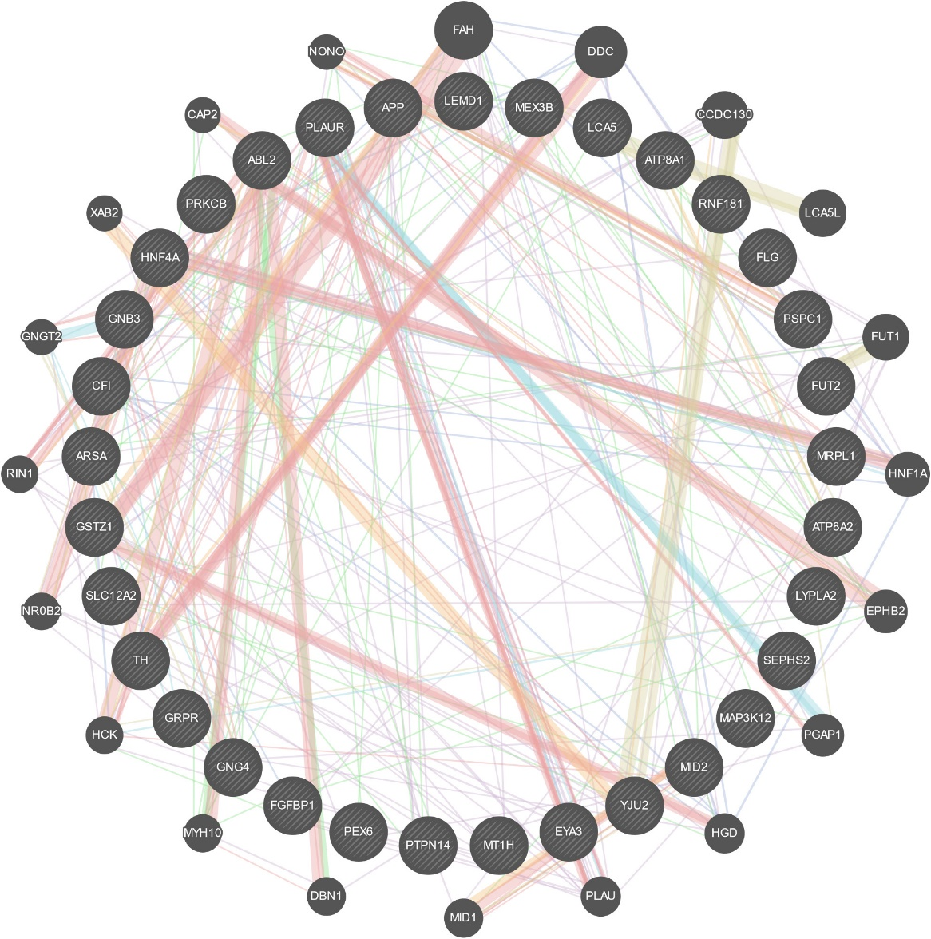

**Figure 1** : The Gen-Gene network for selected Gens .

The drawn network is based on the genes that are explained below.Genes: LYPLA2 , PLAUR , SLC12A2 , MID2 , ARSA , GSTZ1 , HNF4A , YJU2 , GNB3 ,PSPC1 , ATP8A1 , PEX6 , GRPR , ATP8A2 , LCA5 , FGFBP1 , APP , ABL2 ,FLG , EYA3 , PRKCB , GNG4 , RNF181 , MRPL1 , FUT2 , SEPHS2 , TH ,MEX3B , LEMD1 , MT1H , CFI , ZPK , PEZ

Weighting for network was based on Biological process based.

Table 3 shows some genes and their descriptions. These genes are ordered based on the literature and each gene and its explanation is mentioned.

|  |  |  |
| --- | --- | --- |
| Gene | Description | Rank |
| FAH | fumarylacetoacetate hydrolase [Source:HGNC Symbol;Acc:HGNC:3579] | 1 |
| DDC | dopa decarboxylase [Source:HGNC Symbol;Acc:HGNC:2719] | 2 |
| CCDC130 | coiled-coil domain containing 130 [Source:HGNC Symbol;Acc:HGNC:28118] | 3 |
| LCA5L | lebercilin LCA5 like [Source:HGNC Symbol;Acc:HGNC:1255] | 4 |
| FUT1 | fucosyltransferase 1 (H blood group) [Source:HGNC Symbol;Acc:HGNC:4012] | 5 |
| HNF1A | HNF1 homeobox A [Source:HGNC Symbol;Acc:HGNC:11621] | 6 |
| EPHB2 | EPH receptor B2 [Source:HGNC Symbol;Acc:HGNC:3393] | 7 |
| PGAP1 | post-GPI attachment to proteins inositol deacylase 1 [Source:HGNC Symbol;Acc:HGNC:25712] | 8 |
| HGD | homogentisate 1,2-dioxygenase [Source:HGNC Symbol;Acc:HGNC:4892] | 9 |
| PLAU | plasminogen activator, urokinase [Source:HGNC Symbol;Acc:HGNC:9052] | 10 |
| MID1 | midline 1 [Source:HGNC Symbol;Acc:HGNC:7095] | 11 |
| DBN1 | drebrin 1 [Source:HGNC Symbol;Acc:HGNC:2695] | 12 |
| MYH10 | myosin heavy chain 10 [Source:HGNC Symbol;Acc:HGNC:7568] | 13 |
| HCK | HCK proto-oncogene, Src family tyrosine kinase [Source:HGNC Symbol;Acc:HGNC:4840] | 14 |
| NR0B2 | nuclear receptor subfamily 0 group B member 2 [Source:HGNC Symbol;Acc:HGNC:7961] | 15 |
| RIN1 | Ras and Rab interactor 1 [Source:HGNC Symbol;Acc:HGNC:18749] | 16 |
| GNGT2 | G protein subunit gamma transducin 2 [Source:HGNC Symbol;Acc:HGNC:4412] | 17 |
| XAB2 | XPA binding protein 2 [Source:HGNC Symbol;Acc:HGNC:14089] | 18 |
| CAP2 | cyclase associated actin cytoskeleton regulatory protein 2 [Source:HGNCSymbol;Acc:HGNC:20039] | 19 |
| NONO | non-POU domain containing octamer binding [Source:HGNC Symbol;Acc:HGNC:7871] | 20 |

Table 3 . Genes Ranked by literature view .

In the next step, we reviewed the ontology of genes, The **Enrichment**s were based on  **: Biological Process , Molecular Function and Cellular Component .**

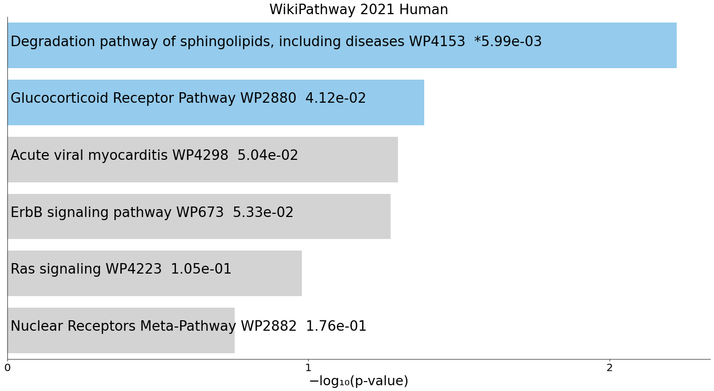

**Figure 2. Bar chart of top enriched terms from the WikiPathway_2021_Human gene set library.** The top 10 enriched terms for the input gene set are displayed based on the -log10(p-value), with the actual p-value shown next to each term. The term at the top has the most significant overlap with the input query gene set.

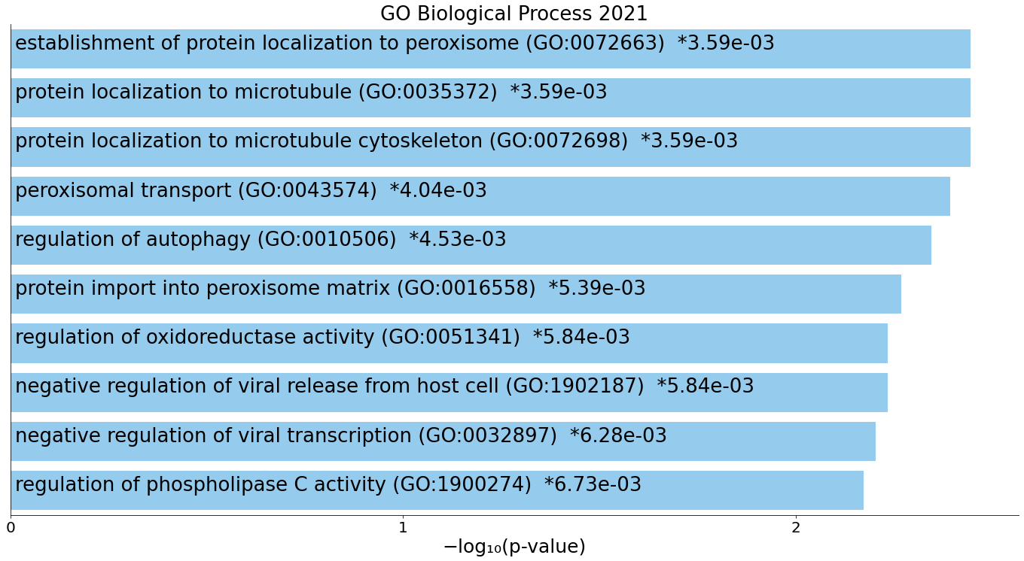**Figure 3. Bar chart of top enriched terms from the GO_Biological_Process_2021 gene set library.** The top 10 enriched terms for the input gene set are displayed based on the -log10(p-value), with the actual p-value shown next to each term. The term at the top has the most significant overlap with the input query gene set.

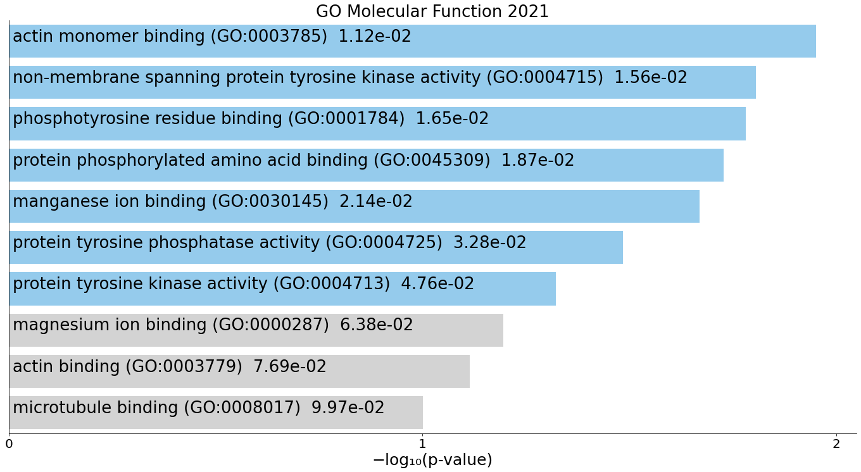

**Figure 4. Bar chart of top enriched terms from the GO_Molecular_Function_2021 gene set library.** The top 10 enriched terms for the input gene set are displayed based on the -log10(p-value), with the actual p-value shown next to each term. The term at the top has the most significant overlap with the input query gene set.

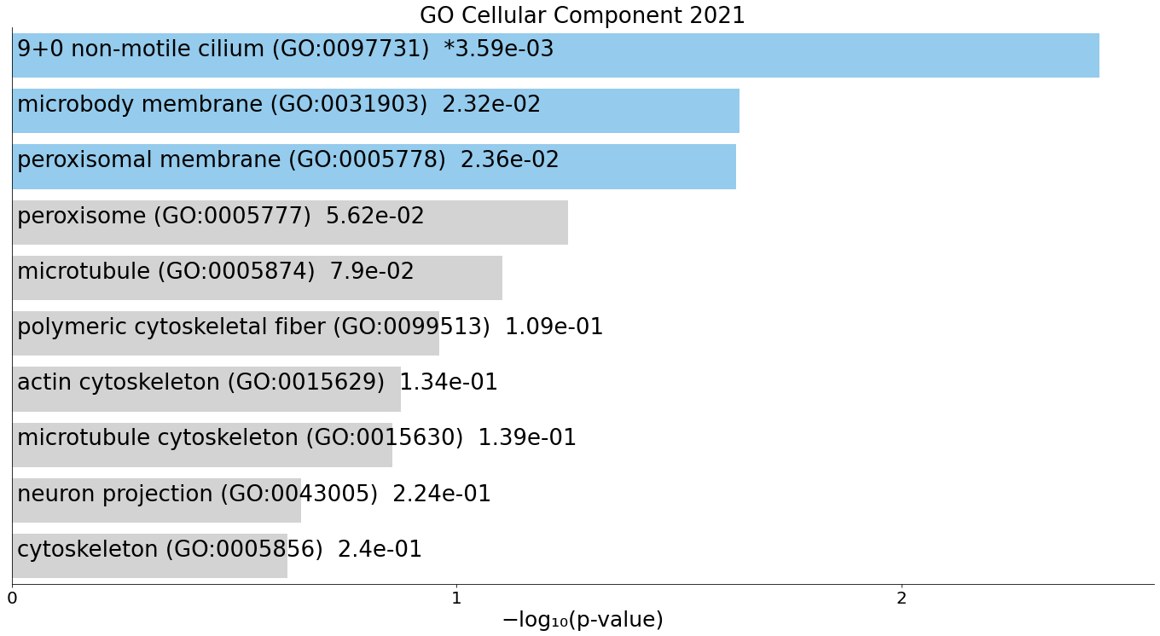

**Figure 5. Bar chart of top enriched terms from the GO_Cellular_Component_2021 gene set library.** The top 10 enriched terms for the input gene set are displayed based on the -log10(p-value), with the actual p-value shown next to each term. The term at the top has the most significant overlap with the input query gene set.